SI Conversion
# Source: AI Source: Provided by: [Data Path: Persons Table -> ID Column: 1, Name_En Column: Motasem Essam] -> From: [ChatGPT] on [7/17/2026]
SI Conversion is the process of changing a measurement from one SI (International System of Units) unit to another equivalent SI unit without changing the actual physical quantity. Since the SI system is based on powers of 10, conversions are simple and are performed by multiplying or dividing by factors of 10.
SI conversion is fundamental in science, engineering, medicine, manufacturing, education, and international standards.

Definition
# Source: AI Source: Provided by: [Data Path: Persons Table -> ID Column: 1, Name_En Column: Motasem Essam] -> From: [ChatGPT] on [7/17/2026]
SI Conversion is the process of converting a measurement from one SI unit to another equivalent SI unit while preserving the same physical quantity.

Purpose
# Source: AI Source: Provided by: [Data Path: Persons Table -> ID Column: 1, Name_En Column: Motasem Essam] -> From: [ChatGPT] on [7/17/2026]
SI conversion is used to:
- Standardize measurements.
- Express quantities in appropriate units.
- Simplify calculations.
- Compare measurements consistently.
- Support international scientific and engineering communication.

Characteristics
# Source: AI Source: Provided by: [Data Path: Persons Table -> ID Column: 1, Name_En Column: Motasem Essam] -> From: [ChatGPT] on [7/17/2026]
SI conversion:
- Uses the International System of Units (SI).
- Is based on decimal (base-10) relationships.
- Does not change the physical quantity.
- Is simple because conversion factors are powers of 10.

SI Base Units
# Source: AI Source: Provided by: [Data Path: Persons Table -> ID Column: 1, Name_En Column: Motasem Essam] -> From: [ChatGPT] on [7/17/2026]
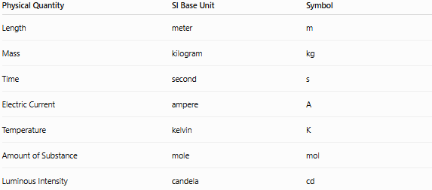
Physical Quantity | SI Base Unit | Symbol
Length | meter | m
Mass | kilogram | kg
Time | second | s
Electric Current | ampere | A
Temperature | kelvin | K
Amount of Substance | mole | mol
Luminous Intensity | candela | cd

SI Prefixes
# Source: AI Source: Provided by: [Data Path: Persons Table -> ID Column: 1, Name_En Column: Motasem Essam] -> From: [ChatGPT] on [7/17/2026]
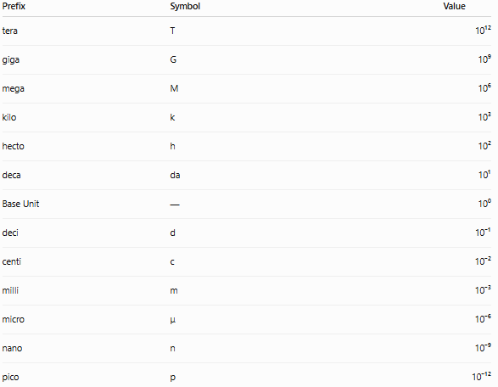
Prefix | Symbol | Value
tera | T | 10¹²
giga | G | 10⁹
mega | M | 10⁶
kilo | k | 10³
hecto | h | 10²
deca | da | 10¹
Base Unit | — | 10⁰
deci | d | 10⁻¹
centi | c | 10⁻²
milli | m | 10⁻³
micro | μ | 10⁻⁶
nano | n | 10⁻⁹
pico | p | 10⁻¹²

Conversion Rule
# Source: AI Source: Provided by: [Data Path: Persons Table -> ID Column: 1, Name_En Column: Motasem Essam] -> From: [ChatGPT] on [7/17/2026]
- Larger unit → Smaller unit: Multiply by powers of 10.
- Smaller unit → Larger unit: Divide by powers of 10.

SI Conversion Ladder
# Source: AI Source: Provided by: [Data Path: Persons Table -> ID Column: 1, Name_En Column: Motasem Essam] -> From: [ChatGPT] on [7/17/2026]
T → G → M → k → h → da → Base → d → c → m → μ → n → p
- Move right → Multiply by 10 for each step.
- Move left → Divide by 10 for each step.

Length Conversions
# Source: AI Source: Provided by: [Data Path: Persons Table -> ID Column: 1, Name_En Column: Motasem Essam] -> From: [ChatGPT] on [7/17/2026]
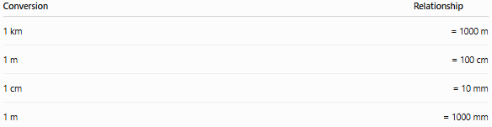
Conversion | Relationship
1 km | = 1000 m
1 m | = 100 cm
1 cm | = 10 mm
1 m | = 1000 mm
Examples
- 3 km = 3000 m
- 4.5 m = 450 cm
- 750 cm = 7.5 m
- 250 mm = 0.25 m

Mass Conversions
# Source: AI Source: Provided by: [Data Path: Persons Table -> ID Column: 1, Name_En Column: Motasem Essam] -> From: [ChatGPT] on [7/17/2026]
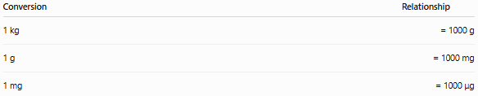
Conversion | Relationship
1 kg | = 1000 g
1 g | = 1000 mg
1 mg | = 1000 μg
Examples
- 2 kg = 2000 g
- 3500 g = 3.5 kg
- 8 g = 8000 mg
- 750 mg = 0.75 g

Time Conversions
# Source: AI Source: Provided by: [Data Path: Persons Table -> ID Column: 1, Name_En Column: Motasem Essam] -> From: [ChatGPT] on [7/17/2026]
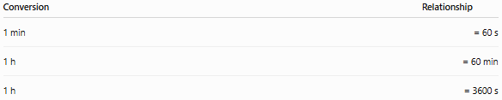
Conversion | Relationship
1 min | = 60 s
1 h | = 60 min
1 h | = 3600 s
Examples
- 2 h = 120 min
- 90 s = 1.5 min
- 7200 s = 2 h
Although minute and hour are accepted for use with SI, the second (s) is the official SI base unit for time.

Capacity Conversions
# Source: AI Source: Provided by: [Data Path: Persons Table -> ID Column: 1, Name_En Column: Motasem Essam] -> From: [ChatGPT] on [7/17/2026]
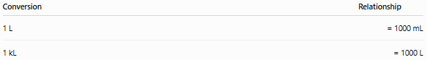
Conversion | Relationship
1 L | = 1000 mL
1 kL | = 1000 L
Examples
- 5 L = 5000 mL
- 2500 mL = 2.5 L
- 3 kL = 3000 L
The liter (L) is not an SI base unit, but it is accepted for use with SI. The SI unit of volume is the cubic meter (m³).

Area Conversions
# Source: AI Source: Provided by: [Data Path: Persons Table -> ID Column: 1, Name_En Column: Motasem Essam] -> From: [ChatGPT] on [7/17/2026]
Area is two-dimensional, so conversion factors are squared.
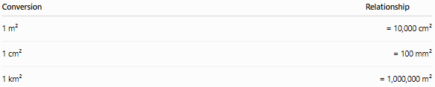
Conversion | Relationship
1 m² | = 10,000 cm²
1 cm² | = 100 mm²
1 km² | = 1,000,000 m²
Examples
- 2 m² = 20,000 cm²
- 500 cm² = 0.05 m²

Volume Conversions
# Source: AI Source: Provided by: [Data Path: Persons Table -> ID Column: 1, Name_En Column: Motasem Essam] -> From: [ChatGPT] on [7/17/2026]
Volume is three-dimensional, so conversion factors are cubed.
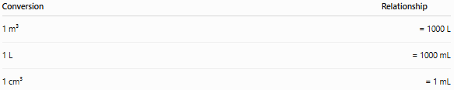
Conversion | Relationship
1 m³ | = 1000 L
1 L | = 1000 mL
1 cm³ | = 1 mL
Examples
- 4 m³ = 4000 L
- 750 mL = 0.75 L
- 35 cm³ = 35 mL

Scientific Notation in SI Conversion
# Source: AI Source: Provided by: [Data Path: Persons Table -> ID Column: 1, Name_En Column: Motasem Essam] -> From: [ChatGPT] on [7/17/2026]
Scientific notation is commonly used for very large or very small SI values.
Examples:
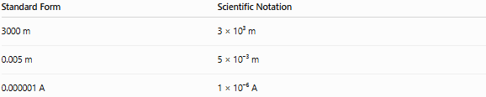
Standard Form | Scientific Notation
3000 m | 3 × 10³ m
0.005 m | 5 × 10⁻³ m
0.000001 A | 1 × 10⁻⁶ A

Applications
# Source: AI Source: Provided by: [Data Path: Persons Table -> ID Column: 1, Name_En Column: Motasem Essam] -> From: [ChatGPT] on [7/17/2026]
SI conversion is used in:
- Physics
- Chemistry
- Engineering
- Medicine
- Manufacturing
- Surveying
- Construction
- Laboratory work
- Education
- International trade

Advantages
# Source: AI Source: Provided by: [Data Path: Persons Table -> ID Column: 1, Name_En Column: Motasem Essam] -> From: [ChatGPT] on [7/17/2026]
SI conversion:
- Uses a simple decimal system.
- Reduces calculation errors.
- Is internationally standardized.
- Simplifies scientific calculations.
- Makes communication consistent worldwide.

Common Mistakes
# Source: AI Source: Provided by: [Data Path: Persons Table -> ID Column: 1, Name_En Column: Motasem Essam] -> From: [ChatGPT] on [7/17/2026]
- Multiplying instead of dividing (or vice versa).
- Misplacing the decimal point.
- Forgetting that area uses squared conversion factors.
- Forgetting that volume uses cubed conversion factors.
- Confusing mass (kg) with weight (N).
- Treating the liter as an SI base unit instead of an accepted non-SI unit.

SI Conversion vs. Metric Conversion
# Source: AI Source: Provided by: [Data Path: Persons Table -> ID Column: 1, Name_En Column: Motasem Essam] -> From: [ChatGPT] on [7/17/2026]
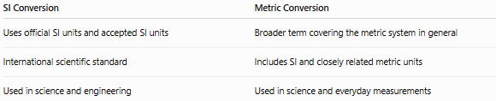
SI Conversion | Metric Conversion
Uses official SI units and accepted SI units | Broader term covering the metric system in general
International scientific standard | Includes SI and closely related metric units
Used in science and engineering | Used in science and everyday measurements

Key Points
# Source: AI Source: Provided by: [Data Path: Persons Table -> ID Column: 1, Name_En Column: Motasem Essam] -> From: [ChatGPT] on [7/17/2026]
- SI Conversion changes the unit, not the quantity.
- It is based on powers of 10.
- Larger → Smaller units: Multiply.
- Smaller → Larger units: Divide.
- Area conversions require squared factors.
- Volume conversions require cubed factors.
- SI conversion is the international standard for scientific and engineering measurements.

Conclusion
# Source: AI Source: Provided by: [Data Path: Persons Table -> ID Column: 1, Name_En Column: Motasem Essam] -> From: [ChatGPT] on [7/17/2026]
SI Conversion is the process of expressing the same physical quantity in different SI units by multiplying or dividing according to powers of 10. Because the SI system is decimal-based, conversions between units such as kilometers and meters, kilograms and grams, or milliliters and liters are straightforward and consistent. Special attention is required when converting area and volume, since their conversion factors must be squared or cubed. Mastering SI conversion is essential for accurate calculations, scientific communication, engineering design, manufacturing, laboratory work, and international standardization.

